**Methodology**

The pollutant data were obtained from NASA's Giovanni (Geospatial Interactive Online Visualization and Analysis Infrastructure https://giovanni.gsfc.nasa.gov/giovanni/). The particulate matter 2.5 (Pm2.5) was obtained for 2018 to 2022, visualized, and exported as a NetCDF file. The file was extracted and spatial interpolation analysis, using the inverse distance weighting (IDW) method was applied.

**SPATIO TEMPORAL CHANGES IN PM 2.5 CONCENTARTION IN ONDO, EKITI AND OSUN STATE FROM 2019 TO 2022**

**Temporal changes in concentration of PM 2.5**

Figure: Trend Analysis of PM2.5 concentration from 2018 to 2022

Source: Author, 2025.

The change and trends in the concentration of PM2.5 in Ondo, Ekiti, and Osun state from 2018 to 2022 is shown in Figure 1.1. An observation in the figure indicates that the concentration of PM2.5 in 2018 was 52.675µg/m³, this was reduced to 41.242µg/m³ in 2019. The change however increased to 55.247µg/m³ in 2020, and 55.250µg/m³ in 2021. This was marginally decreased to 54.990µg/m³ in 2022. The overall trend of the concentration of PM2.5 in Ondo, Ekiti, and Osun States shows an increasing positive trend from 2018 to 2022.

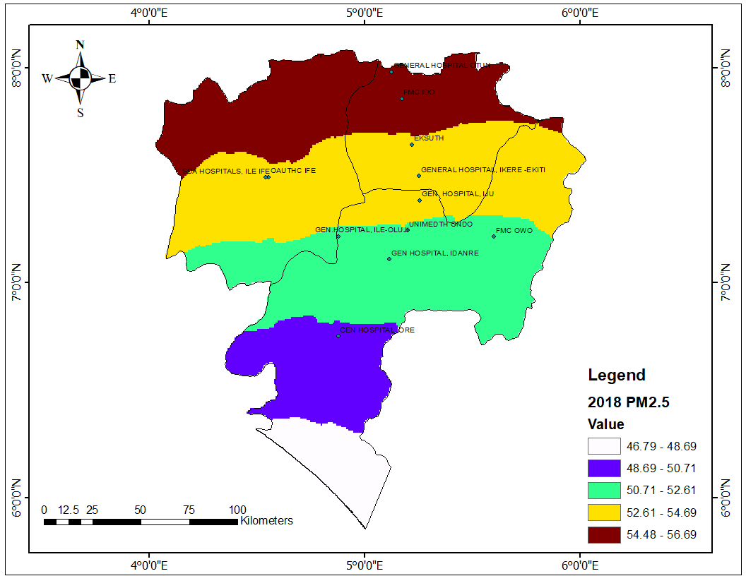**Spatial changes in concentration of PM 2.5 from 2018 to 2022**

Figure 1.2 PM2.5 in the study area, 2018.

Source: Author, 2025

Figure 1.2 displays the analysis of the spatial distribution of the PM2.5 choropleth map. The values of the PM2.5 range from 46.79 to 56.69µg/m³. The values were classed into five (5) groups using the Jenks breaks. The color scale follows an increasing trend, White (46.79 - 48.69 µg/m³), Blue (48.69 - 50.71 µg/m³), Green (50.71 - 52.61 µg/m³), Yellow (52.61 - 54.69 µg/m³), Brown (54.48 - 56.69 µg/m³). Northern regions (brown) have the highest PM2.5 concentration (54.48 - 56.69 µg/m³), indicating worse air quality. Southern areas (blue and white) have the lowest PM2.5 concentration (~46.79 - 50.71 µg/m³), suggesting relatively better air quality. Table 1.2 shows the concentration of air quality in the selected health facilities across the study area. The General hospital Otun, Ekiti recorded the highest concentration of PM2.5 with 56.22(µg/m³), Federal medical center, Ido (55.59µg/m³), Ekiti State University Teaching Hospital (54.2155.59µg/m³), while the lowest concentration was recorded in the General Hospital Ore, Ondo state. The map suggests a north-south gradient, where PM2.5 levels decrease towards the south. Using the WHO, Standard Air Quality (AQI) in Table 1.1, all the areas are far above the standard and very unhealthy.

Table 1.1: World Health Organisation (WHO) Air quality guidelines

|  |  |  |
| --- | --- | --- |
| **PM2.5 Level (µg/m³)** | **WHO AQI Category** | **Health Implications** |
| **0 – 5** | Good | No risk meets WHO standards |
| **5- 15** | Moderate | Some concern for sensitive groups |
| **15 – 25** | Unhealthy for Sensitive Groups | Risks for children, elderly, those with respiratory issues |
| **25 – 35** | Unhealthy | Health effects for the general population |
| **35 – 50** | Very Unhealthy | Increased respiratory and cardiovascular risks |
| **50+** | Hazardous | Severe health risks, emergency conditions |

Source: WHO, Air Quality

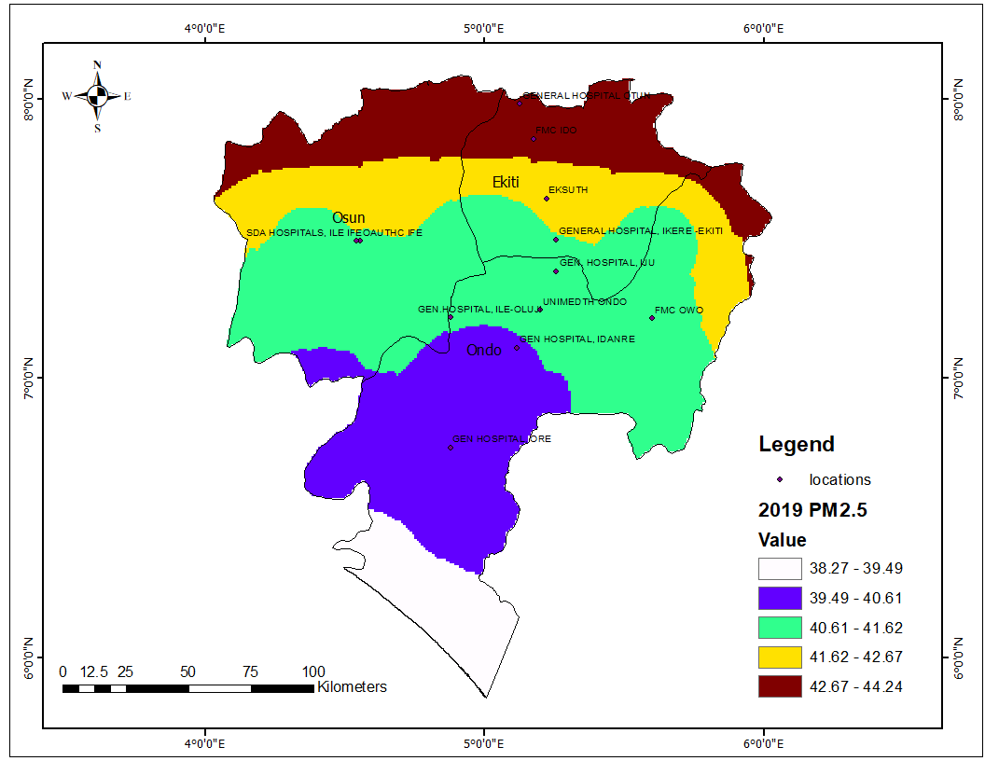Figure 1.3 PM2.5 in the study area, 2019.

Source: Author, 2025

Figure 1.3 shows the PM 2. 5 distributions in Ekiti, Ondo, and Osun states for 2019. The 2019 PM2.5 levels (38.27 – 44.24 µg/m³) are lower than in 2018 (46.79 – 56.69 µg/m³). All areas exceed WHO's annual guideline of 5 µg/m³ by 7–9 times. The lowest concentration (38.27 µg/m³) still far surpasses the recommended limits. The highest PM2.5 level (44.24 µg/m³) is in the northern regions (Ekiti and Osun). The southern region (Ondo) has relatively lower PM2.5 values (38.27 – 40.61 µg/m³), indicating better air quality compared to the north. The information from the attribute the Table 1.2 showing the concentration of PM2.5 pollutants indicated that the Pm 2.5 concentration at the General Hospital Otun decreased to 43.48µg/m³ from 56.22µg/m³ in the previous year, while FMC, Ido (43.09µg/m³), EKSUTH (41.96µg/m³), SDA Hospitals, Ile Ife (41.52µg/m³), General Hospital, Ile-Oluji (40.76µg/m³) while the lowest concentration recorded in General Hospital Ore (40.11µg/m³).

**Table 1.2: PM 2.5 concentration (µg/m³) across the Ondo, Ekiti and Osun State from 2018 to 2022**

|  |  |  |  |  |  |
| --- | --- | --- | --- | --- | --- |
| Location | PM2.5 2018  (µg/m³) | PM2.5 2019  (µg/m³) | PM2.5 2020  (µg/m³) | PM2.5 2021  (µg/m³) | PM2.5 2022  (µg/m³) |
| EKSUTH | 54.21 | 41.96 | 56.73 | 56.89 | 56.78 |
| FMC IDO | 55.59 | 43.09 | 58.18 | 58.68 | 58.51 |
| GENERAL HOSPITAL, IKERE EKITI | 53.50 | 41.44 | 56.01 | 55.99 | 55.93 |
| GENERAL HOSPITAL OTUN | 56.22 | 43.48 | 58.80 | 59.38 | 59.18 |
| OAUTHC IFE | 54.19 | 41.53 | 56.31 | 56.23 | 55.23 |
| SDA HOSPITALS, ILE IFE | 54.20 | 41.52 | 56.31 | 56.23 | 55.21 |
| FMC OWO | 52.20 | 41.29 | 55.31 | 55.06 | 55.02 |
| UNIMEDTH ONDO | 52.46 | 40.97 | 55.13 | 54.67 | 54.78 |
| GEN HOSPITAL, ORE | 50.34 | 40.11 | 53.02 | 51.82 | 52.68 |
| GEN.HOSPITAL, ILE-OLUJI | 52.37 | 40.76 | 54.86 | 54.26 | 54.38 |
| GEN HOSPITAL, IDANRE | 51.59 | 40.42 | 54.22 | 53.33 | 53.70 |
| GEN. HOSPITAL, IJU | 52.92 | 41.19 | 55.53 | 55.32 | 55.33 |

Source: Author, 2025.

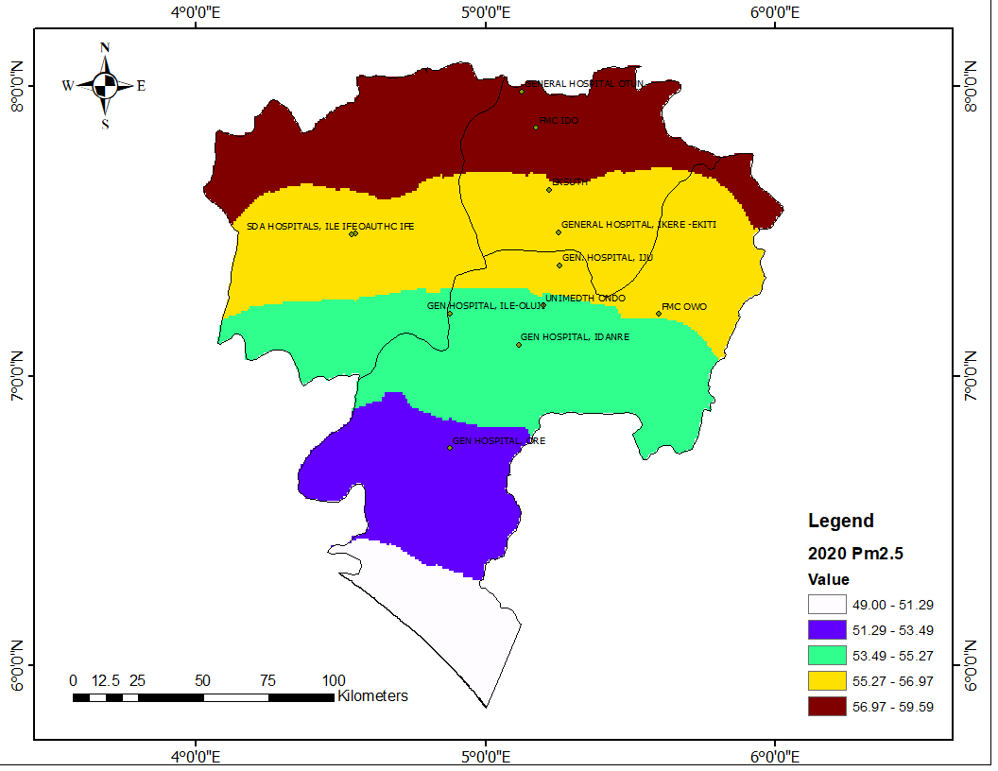Figure 1.4 Pm 2.5 across the study area, 2020

Source: Author, 2025

Figure 1.3 shows the Pm 2.5 across Ekiti, Ondo and Osun state. The northern region has the highest PM2.5 concentration (56.97 – 59.59 µg/m³) including locations like General Hospital Otun (58.80 µg/m³) and FMC Ido (58.18 µg/m³). There is a significant increase in PM 2.5 across the states compared to the previous year 2019. High values of Pm2.5 was recorded in Ikere Ekiti (56.01 µg/m³), EKSUTH (56.73µg/m³), General Hospital, Iju (55.53µg/m³), and SDA Ile Ife (56.31µg/m³), moderate levels of Pm2.5 level ranging from 53.49 to 55.27 µg/m³ were observed in hospitals like UNIMEDTH Ondo (55.13 µg/m³) and General Hospital, Idanre (54.22 µg/m³). The lower concentrations (51.29 – 53.49 µg/m³), were observed in General Hospital, Ore (53.02 µg/m³), while the southernmost region the lowest PM2.5 levels.

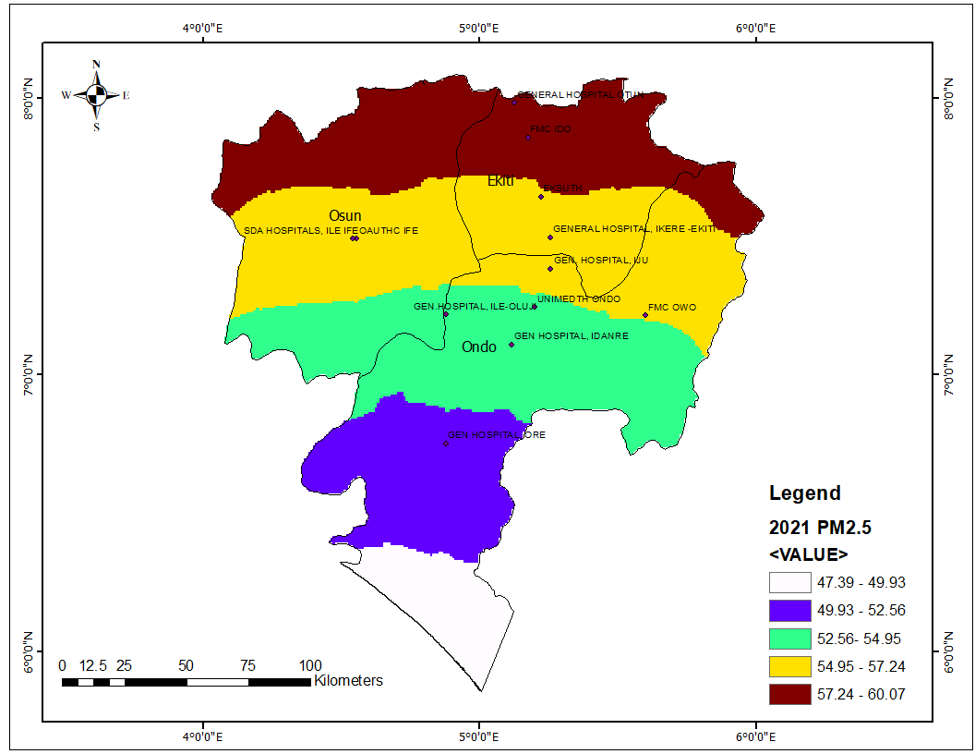

Figure 1.5. Pm 2.5 across Ondo, Ekiti and Osun state 2021

Source: Author, 2025

The concentration of PM2.5 across Ondo, Ekiti and Osun state, 2021 is shown in figure 1.5. When compared to the previous year 2020 with reference to Table 1.2, the concentration in most of the health facilities indicated higher values of Pm 2.5 while some areas recorded reduced Pm2.5. Facilities like Ekiti state teaching hospital had increased value of 56.89µg/m³, FMC (58.68µg/m³), General hospital Otun (59.38µg/m³), and UNIMEDITH Ondo(54.67µg/m³) all had increased concentration of PM2.5, while General Hospital Ikere had lower value compared to the previous year with the Pm 2.5 value (55.99µg/m³), OAUTHC (56.23µg/m³), SDA Ife (56.23µg/m³), FMC Owo (55.06µg/m³), General Hosital |Ore (51.82µg/m³), General Hospital Ile-Oluji (54.26µg/m³), and General Hospital Iju (55.32µg/m³). However, all the values exceed the World Health 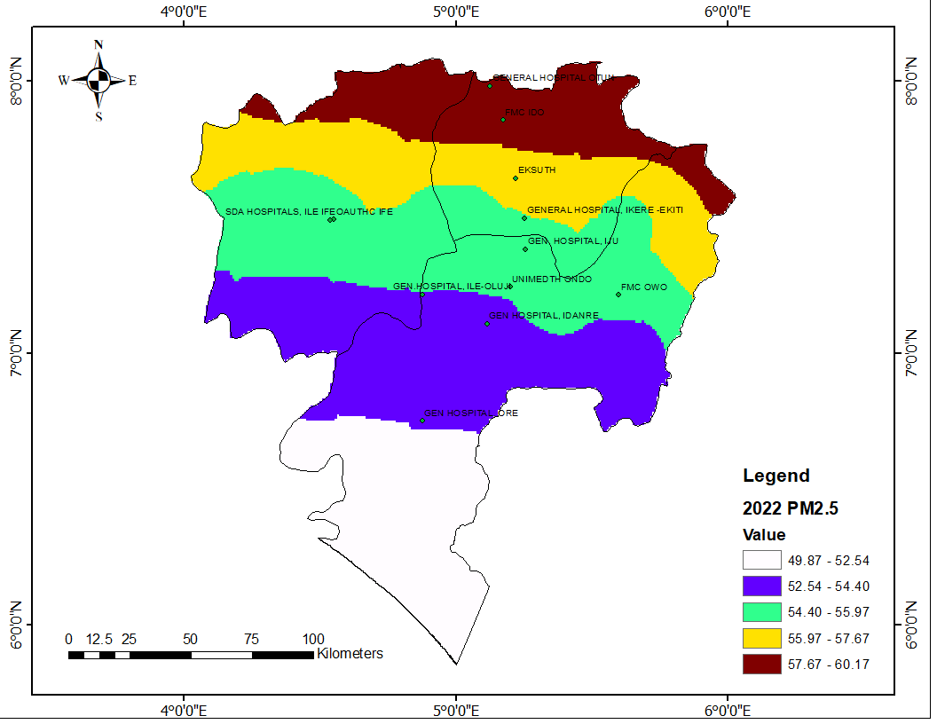Organization Air Quality standard.

Figure 1.6: Pm 2.5 concentration across Ondo, Ekiti and Osun state, 2022.

Source: Author, 2025.

The concentration of Particulate matter 2.5 in 2022 as shown in the figure 1.6 and the attribute Table 1.2 shows the temporal changes in the concentration of the pollutants across the states and the public health facilities. The concentration among the facilities fluctuates over temporal period indicating that there are spatial factors contributing to the fluctuating of the concentration across the states. In 2022, there was generally decreased value of Pm2.5 in most places like Ekiti state Teaching Hospital (EKSUTH), FMC Ido, General Hospital Ikere, General Hospital Otun, General Hospital Ore, while General Hospital Iju, Idanre, Idanre, and UNIMEDTH had increased values.

**SPATIO-TEMPORAL CHANGES IN SULPHUR IV OXIDE IN ONDO, EKITI, AND OSUN STATES FROM 2019 TO 2022**

FIGURE 1.7: Temporal changes in Sulphur IV Oxide concentration from 2018 to 2022

Source: Author, 2025

The average concentration of Sulphur IV Oxide trend analysis from 2018 to 2022 in Ondo, Ekiti, and Osun states is displayed in Figure 1.7. The figure shows that the average concentration of Sulphur IV Oxide in 2018 was 0.5434µg/m³, which reduced to 0.5167 µg/m³ in 2019. However, the average concentration rebounded above the level it was after the decrease in 2019 to 0.5989µg/m³ in 2020, the upward trend was maintained in 2021 with an average concentration of 0.6308, is followed by a marginal decrease in 2022 to 0.6091µg/m³. The overall trend of the average concentration of Sulphur IV Oxide indicated an increasing positive trend, which could result from increasing anthropogenic activities that increase the concentration of Sulphur IV Oxide released into the environment. However, these values are below the World Health Organization (WHO), Air Quality guidelines which stipulate 500 µg/m³ per 10 minutes, and 20 µg/m³ per 24 hours (day).

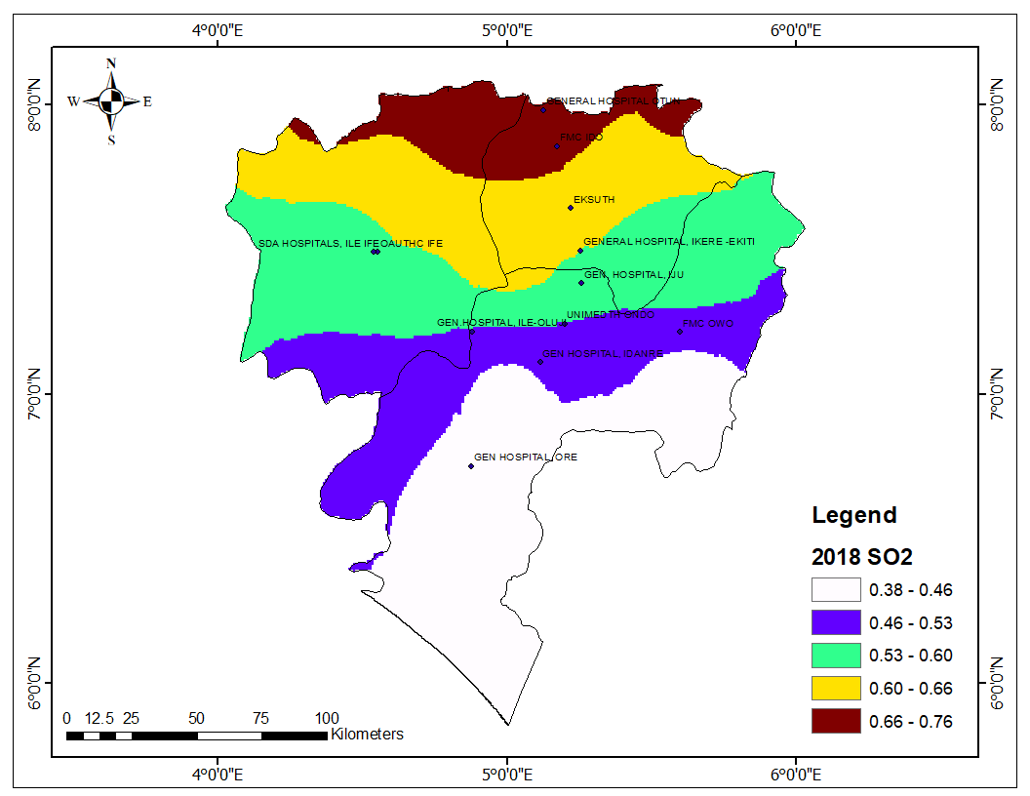**Spatial Changes in Sulphur IV Oxide Concentration from 2018 to 2022**

Figure 1.8: Concentration of Sulphur IV Oxide in 2018

Source: Author, 2025.

The concentration of Sulphur IV Oxides as shown in Figure 1.8 range from 0.38 to 0.76 across Ondo, Ekiti, and Osun State in 2018. The choropleth map shows the areas that have the lowest concentration in white colour (0.38 – 0.46), Low concentration in blue (0.46 – 0.53), Moderate concentration in Green (0.53 – 0.60), High in yellow colour (0.60 – 0.66), and very high in red color (0.66 – 0.76). The level of concentration for health facilities is displayed in Table 1.3, General hospital Otun, Ekiti has the highest concentration of Sulphur IV Oxide with 0.72µg/m³, FMC IDO (0.68 µg/m³), EKSUTH(0.63), however, the value is good and below the World Health Organization guidelines.

**Table 1.3: Sulphur IV Oxide concentration** SO2 **(µg/m³) across the Ondo, Ekiti, and Osun States from 2018 to 2022.**

|  |  |  |  |  |  |
| --- | --- | --- | --- | --- | --- |
| Location | 2018  SO2  (µg/m³) | 2019  SO2  (µg/m³) | 2020  SO2  (µg/m³) | 2021  SO2  (µg/m³) | 2022  SO2  (µg/m³) |
| EKSUTH | 0.63 | 0.59 | 0.67 | 0.73 | 0.68 |
| FMC IDO | 0.68 | 0.64 | 0.71 | 0.79 | 0.73 |
| GENERAL HOSPITAL, IKERE -EKITI | 0.60 | 0.56 | 0.64 | 0.70 | 0.66 |
| GENERAL HOSPITAL OTUN | 0.72 | 0.68 | 0.74 | 0.83 | 0.76 |
| OAUTHC IFE | 0.58 | 0.55 | 0.63 | 0.67 | 0.63 |
| SDA HOSPITALS, ILE IFE | 0.58 | 0.55 | 0.63 | 0.67 | 0.63 |
| FMC OWO | 0.49 | 0.47 | 0.57 | 0.59 | 0.57 |
| UNIMEDTH ONDO | 0.53 | 0.50 | 0.59 | 0.62 | 0.60 |
| GEN HOSPITAL, ORE | 0.44 | 0.42 | 0.52 | 0.52 | 0.52 |
| GEN.HOSPITAL, ILE-OLUJI | 0.53 | 0.50 | 0.59 | 0.61 | 0.60 |
| GEN HOSPITAL, IDANRE | 0.48 | 0.45 | 0.55 | 0.56 | 0.55 |
| GEN. HOSPITAL, IJU | 0.56 | 0.53 | 0.62 | 0.66 | 0.63 |

**Source: Author, 2025**

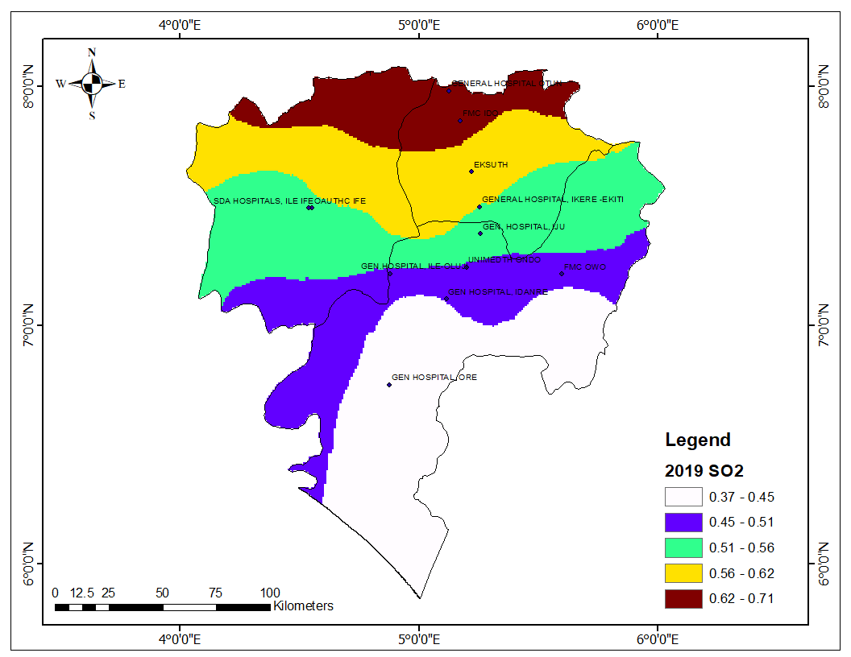

Figure 1.9: Concentration of Sulphur IV Oxide in 2019

Source: Author, 2025.

Figure 1.9 represents the concentration of Sulphur IV Oxide in Ondo, Ekiti, and Osun states in 2019 ranging from 0.37 – 0.71µg/m³. In 2019, the concentration of SO2 in all the states was generally lower than in 2018, likewise, the concentration of SO2 at the selected hospitals recorded a lower concentration or instance, EKSUTH recorded 0.59µg/m³ from the previous 0.63µg/m³, FMC IDO 0.64µg/m³ from 0.68µg/m³. The general hospital Otun recorded 0.68µg/m³ which was the highest value in 2019, while the general hospital Iju recorded the lowest 0.42µg/m³. The location of these two (2) hospitals is at the Northernmost and southernmost part of the states, indicating that the SO2 pollutants increase from the southern part to the Northern Part of Nigeria.

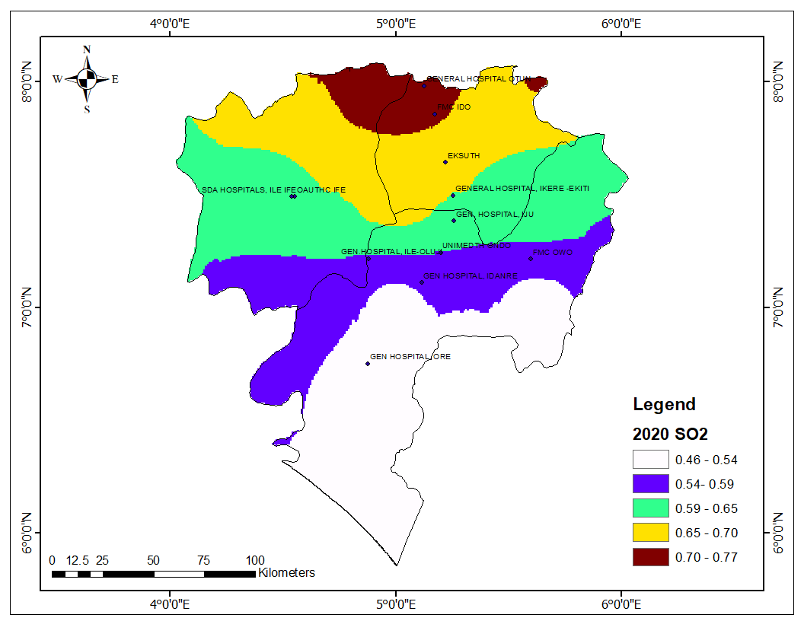Figure 1.9: Concentration of Sulphur IV Oxide in 2020

Source: Author, 2025.

The concentration of Sulphur IV Oxide (SO2) in the selected states in 2020 as shown in Figure 1.9 indicated that the range of the pollutant is from 0.46 to 0.77µg/m³. It is observed in the map that the areas with very high concentrations reduced significantly. However, the average SO2 for the year increased from 0.5167 µg/m³ in 2019 to 0.5989µg/m³ in 2020 with a standard deviation of

Comparing the sulfur dioxide (SO₂) concentration data for 2020 and 2019, it is evident that there was a general increase in SO₂ levels across all locations. For instance, at EKSUTH, the SO₂ concentration rose from 0.59 µg/m³ in 2019 to 0.67 µg/m³ in 2020. A similar trend is observed at FMC IDO, where levels increased from 0.64 µg/m³ to 0.71 µg/m³. Other locations, such as General Hospital, Ikere-Ekiti, and General Hospital, Otun, also experienced noticeable increases, with values rising from 0.56 µg/m³ to 0.64 µg/m³ and from 0.68 µg/m³ to 0.74 µg/m³, respectively.

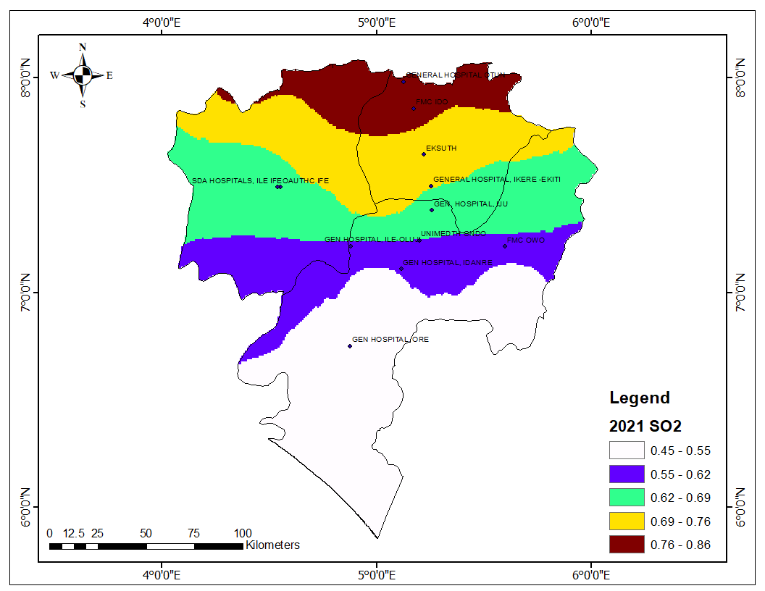This general increase in SO₂ concentration between 2019 and 2020 suggests a worsening trend in air quality. The rise in pollution levels may be linked to increased industrial activities, vehicular emissions, or other anthropogenic factors. The impact of these changes is particularly concerning, considering the World Health Organization (WHO) air quality guidelines for sulphur dioxide. According to WHO standards, the 24-hour average SO₂ concentration should not exceed 20 µg/m³, and the annual average should remain significantly lower. The values recorded in both 2019 and 2020 are well below these limits. However, localized increases could still pose health risks, particularly for vulnerable populations such as individuals with respiratory conditions.

Figure 1.10: Concentration of Sulphur IV Oxide in 2021

Source: Author, 2025.

Figure 1.10 shows the Sulphur dioxide (SO₂) concentration in 2021. The information from the attribute table 1.3 indicated that SO2 continued to rise across various locations, which indicates a persistent decline in air quality. Areas that had already shown an increase in SO₂ levels in 2020 experienced a further elevation in 2021. For instance, the concentration at FMC IDO, which was 0.71 µg/m³ in 2020, increased further to 0.78 µg/m³ in 2021. Also, at General Hospital, Otun, the SO₂ concentration rose from 0.74 µg/m³ in 2020 to 0.81 µg/m³ in 2021. The spatial distribution of SO₂ also shows that regions with higher concentrations in 2020 maintained or expanded their elevated levels in 2021. The northern part of the study area, particularly around General Hospital, Ido, and EKSUTH, experienced a notable increase, crossing into the 0.76–0.86 µg/m³ range, as depicted in the darkest shade on the map. Other locations, such as FMC Owo and General Hospital, Ikere-Ekiti, also witnessed a steady rise, aligning with the overall trend of increasing SO₂ levels.

Although these values remain below the WHO’s air quality guideline of 20 µg/m³ for the 24-hour average, the consistent rise is concerning.

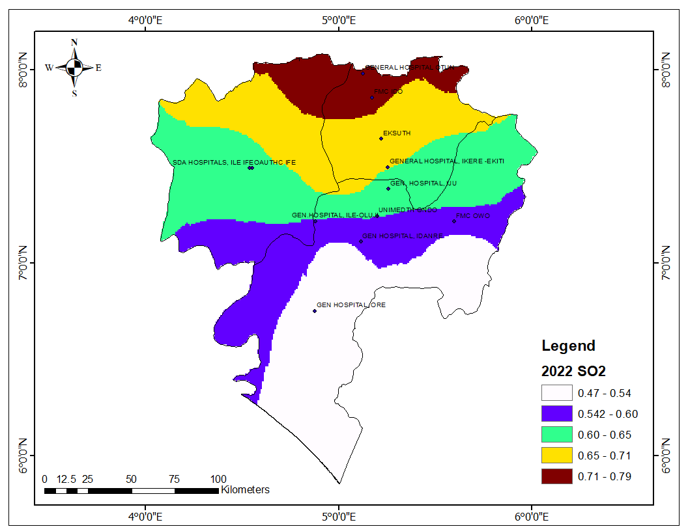Figure 1.11: Concentration of Sulphur IV Oxide in 2022

Source: Author, 2025

The concentration of Sulphur IV Oxide in Odo, Ekiti, and Osun for 2022 is displayed in Figure 1.11, unlike the continuous increase observed from 2019 to 2021, the 2022 data experienced a slight reduction in SO₂ levels across some areas while others remained consistently high. Likewise, the average concentration of SO2 decreased from 0.6308µg/m³ to 0.6091µg/m³ 2022, there was also a visible reduction in SO₂ levels in certain locations. For instance, regions that previously recorded values in the 0.76–0.86 µg/m³ range in 2021, such as areas around FMC IDO and General Hospital, Otun, now show slightly lower values in the 0.71–0.79 µg/m³ range. Moreover, other regions have seen SO₂ levels drop into lower concentration brackets, particularly in the central and southwestern parts of the study area. However, the northern part, including areas around EKSUTH and FMC IDO, continued to experience relatively high SO₂ levels, indicating that pollution sources in these locations remain significant. However, the recorded values, are all below the WHO's 24-hour average guideline of 20 µg/m³

**Incidence of Asthma across the Ondo, Ekiti, and Osun State within the selected public health facilities.**

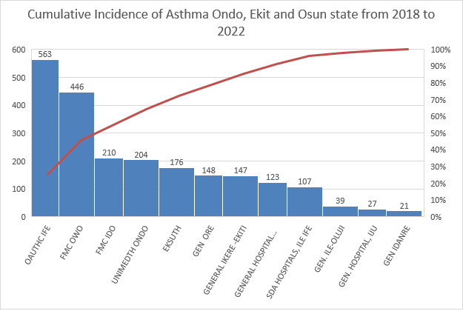

Figure 1.6: Cumulative incidence of Asthma in Ondo, Ekiti and Osun state (2018 – 2022)

Source: Author, 2025

Figure 1.6 shows the cumulative cases of Asthma in Ondo, Ekiti, and Osun state from 2018 to 202. The figure shows that the highest incidence of Asthma was recorded in Obafemi Awolowo Teaching Hospital, Ile Ife with 563cases, FMC Owo (446cases), FMC Ido (210), UNIMEDTH (204) while low cases were recorded in General Hospital Idanre (21cases), general Hospital Iju (27) and General Hospital Ile Oluji (39). In comparison of this cumulative cases with the map of PM2.5 across the states, most public health facilities that recorded low values are within areas where concentration of PM 2.5 were low or moderate values. Information from the attribute table showing the cases of asthmatic patients across the states shows that high cases of Asthma was recorded in 2018 when compared to other years, for instance EKSUTH recorded the highest value of 176 cases, FMC Ido (210), General Hospital Ikere (147), OAUTHC (563cases), FMC Owo (446), while low cases were recorded general Hospital Idanre (21), General hospital Iju (27), and General Hospital Ile-Oluji (39).

Table 1.4 Incidence of Asthma in Ondo, Ekiti and Osun states

|  |  |  |  |  |  |
| --- | --- | --- | --- | --- | --- |
| Location | ASTHMA 2018 | ASTHMA 2019 | ASTHMA 2020 | ASTHMA 2021 | ASTHMA  2022 |
| EKSUTH | 176 | 115 | 140 | 155 | 116 |
| FMC IDO | 210 | 192 | 181 | 201 | 140 |
| GENERAL IKERE -EKITI | 147 | 108 | 90 | 76 | 94 |
| GENERAL HOSPITAL OTUN | 123 | 66 | 55 | 76 | 94 |
| OAUTHC IFE | 563 | 525 | 257 | 396 | 423 |
| SDA HOSPITALS, ILE IFE | 107 | 100 | 35 | 73 | 99 |
| FMC OWO | 446 | 285 | 230 | 179 | 169 |
| UNIMEDTH ONDO | 204 | 184 | 164 | 137 | 103 |
| GEN ORE | 148 | 0 | 113 | 58 | 148 |
| GEN. ILE-OLUJI | 39 | 31 | 56 | 43 | 56 |
| GEN IDANRE | 21 | 76 | 42 | 32 | 56 |
| GEN. HOSPITAL, IJU | 27 | 21 | 8 | 2 | 6 |

**Relationship between Asthma, Particulate Matter 2.5 (PM2.5), and socioeconomic characteristics.**

A regression analysis was conducted to test the impacts of PM 2.5 pollutants and socioeconomic status (Gender and Age) on the incidence of Asthma across the states. Table 1.5 shows the regression result of the relationship between the dependent variable (Asthma) and independent variables (PM2.5, Age, and Gender). The table shows that Female Gender, and Age (61-80) are susceptible to Asthma at a Significant level (0.05), while PM 2.5 (1.708), Female (1.975), Male (-0.521), and age 61-80 (1.391). The Adjusted R-squared value of 0.892 indicates that approximately 89.2% of the variation in asthma incidence across states can be explained by the independent variables in the model. The results indicate a positive association between PM2.5 levels and asthma cases, indicating that higher pollution by PM2.5 levels may be linked to increased asthma incidence. At the same time, aged people are linked to more asthma cases which could be because of accumulation of PM2.5 in their body system and the accumulation of other factors triggering Asthma over time. The result also indicated fewer males recorded fewer asthma cases at the 0.1 (90%) significance level.

The regression equation at significance level 0.1 is represented below

Table 1.5: Regression results on the relationship between PM2.5, age and gender.

$$Asthma= -82.92+\left(1.708 × PM2.5\right)+\left(1.975 × Female\right)+\left(-0.521 × Male\right)+(1.391 × Age 61-80)$$

|  |  |  |  |  |  |  |
| --- | --- | --- | --- | --- | --- | --- |
| **Coefficients** | | | | | | |
| Model | | Unstandardized Coefficients | | Standardized Coefficients | t | Sig. |
| B | Std. Error | Beta |
| 1 | (Constant) | -82.922 | 53.820 |  | -1.541 | .130 |
| PM2.15 | 1.708 | 1.015 | .079 | 1.683 | .099 |
| FEMALE | 1.975 | .308 | 1.200 | 6.415 | .000 |
| MALE | -.521 | .275 | -.238 | -1.895 | .064 |
| AGE20-41 | -.199 | .305 | -.076 | -.653 | .517 |
| AGE41-20 | .094 | .293 | .043 | .321 | .750 |
| AGE41-60 | -.703 | .462 | -.196 | -1.520 | .135 |
| AGE61-80 | 1.391 | .510 | .384 | 2.729 | .009 |
| AGE81-100 | .405 | .427 | .060 | .948 | .348 |
| a. Dependent Variable: ASTHMA | | | | | | |

|  |  |  |  |  |
| --- | --- | --- | --- | --- |
| **Model Summary** | | | | |
| Model | R | R Square | Adjusted R Square | Std. Error of the Estimate |
| 1 | .953a | .908 | .892 | 40.234 |
| a. Predictors: (Constant), AGE81-100, FEMALE, PM2.15, AGE61-80, AGE20-41, AGE41-60, MALE, AGE61-20 | | | | |

**Relationship between Asthma, Sulphur IV Oxide (SO2), and socioeconomic characteristics.**

Table 1.6: Regression result between Sulphur IV Oxide, age and gender

|  |  |  |  |  |  |  |
| --- | --- | --- | --- | --- | --- | --- |
| **Coefficients** | | | | | | |
| Model | | Unstandardized Coefficients | | Standardized Coefficients | t | Sig. |
| B | Std. Error | Beta |
| 1 | (Constant) | -50.176 | 41.386 |  | -1.212 | .231 |
| SO2 | 95.296 | 67.817 | .066 | 1.405 | .166 |
| FEMALE | 1.957 | .307 | 1.188 | 6.376 | .000 |
| MALE | -.533 | .278 | -.244 | -1.918 | .061 |
| YEAR120 | .101 | .292 | .046 | .345 | .731 |
| YEAR2140 | -.257 | .303 | -.097 | -.848 | .400 |
| YEAR4160 | -.515 | .451 | -.144 | -1.141 | .259 |
| YEAR6180 | 1.280 | .497 | .353 | 2.576 | .013 |
| YEAR81100 | .398 | .428 | .059 | .929 | .357 |
| a. Dependent Variable: ASTHMA | | | | | | |

The relationship between the incidence of asthma in Ondo, Ekiti, and Osun state was tested with a linear regression, with Asthma as independent variables and age and gender as the dependent variables. Table 1.6 shows the result of the regression analysis, the table reveals that gender and age significantly influence asthma prevalence. In particular, females exhibit a significantly higher prevalence of asthma compared to males, with a strong statistical significance (p < 0.001). Moreso, individuals aged 61 to 80 years also show a significantly higher likelihood of asthma, indicating that asthma prevalence increases with age in this group (p = 0.013). The R-Square value of 0.907 suggests that approximately 90.7% of the variation in asthma cases can be explained by the included predictors, which is quite substantial. The Adjusted R Square, slightly lower at 0.892, accounts for the number of predictors in the model and still supports a strong explanatory power. These findings suggest that biological and age-related factors play a crucial role in asthma occurrence. However, while SO₂ levels show a positive association with asthma, the relationship is not statistically significant, implying that other factors may have a stronger influence on asthma prevalence. The reason for the lack of significance is that the recorded SO₂ levels remain below the World Health Organization (WHO) air quality guidelines, indicating that exposure may not be high enough to strongly impact asthma cases.

|  |  |  |  |  |
| --- | --- | --- | --- | --- |
| **Model Summary** | | | | |
| Model | R | R Square | Adjusted R Square | Std. Error of the Estimate |
| 1 | .952a | .907 | .892 | 40.1861896 |
| a. Predictors: (Constant), YEAR81100, FEMALE, SO2, YEAR6180, YEAR2140, YEAR4160, MALE, YEAR120 | | | | |